Monday | Tuesday | Wednesday |  | Thursday | Friday
 |  |  |  | 1  Self- Determination:  Choosing July Activities  Game Day! | 2  Day to Day:  Revisit Personal Hygiene/ Spa Day  Project Stir
5  Health & Wellness:  Positive Self–Talk Flower Activity | 6  Arts & Crafts:  Make your Own Pinch Pot  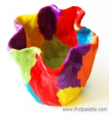 | 7  Cooking Class:  Taco in a Bag  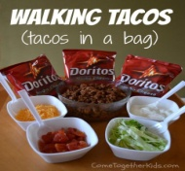 |  | 8  Community Integration:  Cabin Creek Golf  Pack a cold Lunch  $10.00 | 9  Science:  Making Floam  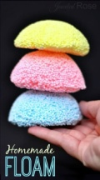
12  CLOSED for  Staff-In-service | 13  Birthday Celebration:  Pizza Party  $6.00 | 14  Community Integration:  Hershberger Farms  Bring $ for purchases |  | 15  Life Skills:  Fire & Safety Drills  Project Stir | 16  Water Fun Day:
19  Order- In  $7.00  Outdoor Gardening | 20  Science:  Uncovering secret messages | 21  Day to Day:  How to sew on a button  Project stir | 22  Picnic @ the Park:  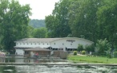  Bring your favorite side dish  (Hot Dogs will be provided) |  | 23  Cooking Class:  Make your own Popsicle  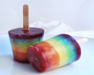
26  Life Skills: Sewing Class  Writing to Pen Pals | 27  Community Integration:  Lunch @ Earls Ice Cream Shop  Bring $ for purchases | 28  Arts & Crafts:  Tin Can Wind Chimes  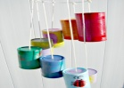 | 29  Community Integration:  The Works of Newark  Pack a cold lunch  $10.00 |  | 30  Health Wellness:  Walking At the Park  Cooking Class:  Rainbow Cookies
