Monday |  | Tuesday | Wednesday |  | Thursday | Friday
3  CLOSED | 4  CLOSED |  | 5  MAKE A FLAG  WHAT IS THE 4TH OF JULY? |  | 6  VOLUNTEER AT THE GROVE  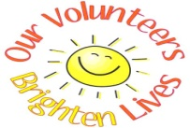 | 7  BOWLING $4.50  CHOOSING ACTIVITIES FOR AUGUST
10  LUNCH AT DAWES PACK A COLD LUNCH  SAFETY DRILLS |  | 11  DEVELOPING HEALTHY RELATIONSHIPS  LETS TAKE A WALK! | 12  ADS GET TOGETHER!  PACK A COLD LUNCH  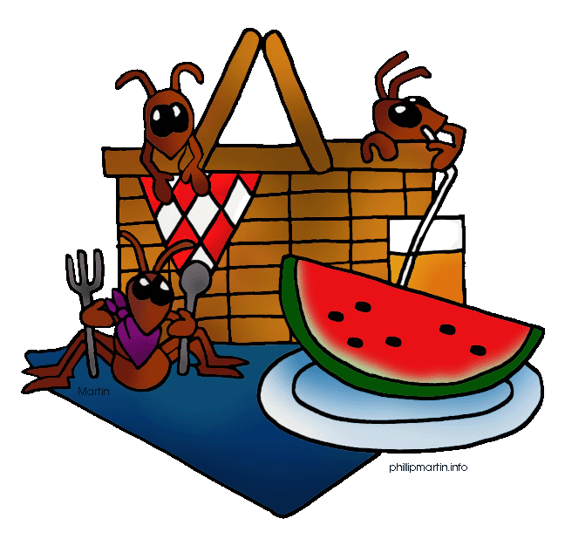 |  | 13  VOLUNTEER AT THE GROVE | 14  ANNARINOS: LEARNING MARTIAL ARTS
17  WALK AT BLACKHAND GORGE  WHAT MAKES THE SUN HOT! |  | 18  SCRAPBOOKING!  WHAT AM I? LEARNING DIFFERENT TEXTURS | 19  WALK TO THE LIBRARY  PROJECT STIR |  | 20  VOLUNTEER AT THE GROVE  TOGETHER WE GROW: GREEN DREAMS CREW | 21  YE OLD MILL/ ICE CREAM $5  SAFETY DRILLS
24  PUTT PUTT $8  PROJECT STIR |  | 25  COOKING CLASS: HEALTHY PASTA SALAD  LEARNING A NEW GAME | 26  TOGETHER WE GROW  KARAOKE |  | 27  VOLUNTEER AT THE GROVE | 28  COLVIN AND EASTLAND COOKOUT! *BRING A COVERED DISH*
31
ORDER IN FROM LITTLE CEASARS $2

MOVIE!
JULY

