Monday | Tuesday | Wednesday | Thursday | Friday
 |  |  | 1  Sensory Class  Making Slim 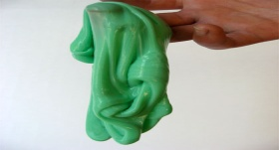 | 2  Controlling Emotion in work place
5  Social  Game day..  Balloon Toss | 6  Health & wellness  Ball toss | 7  Fun Facts  On February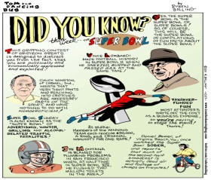 | 8  Choosing activities  For March | 9  Fire Safety drills
12  Game Day  Playing on the Wii 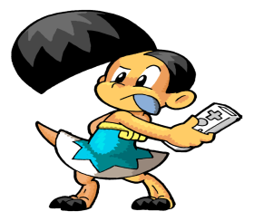 | 13  Baking Class  Heart Cookies | 14  Valentine’s Day  Party . | 15  Project stir  Communication | 16  Tornado Drills
19  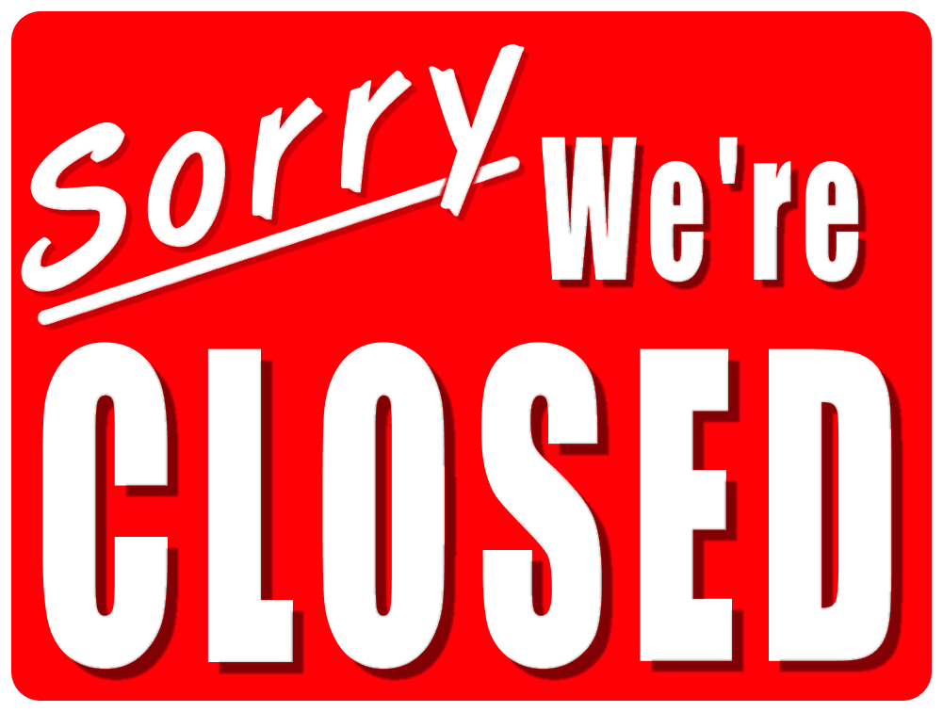 | 20  Avalon Clean up day | 21  Life skill  Personal Hygiene | 22  Employability  Behaviors That should not be done in the work place | 23  Health & Wellness  ABC Exercise
26  Health & Wellness  Chair Exercise | 27  Project Stir  Problem Solving | 28  Movie Day  Bring in Your Favorite Movie to watch
February 2018

