Monday | Tuesday | Wednesday |  | Thursday | Friday
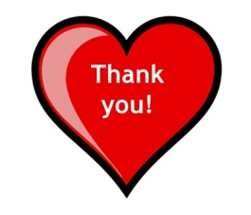 | 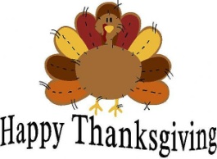 | 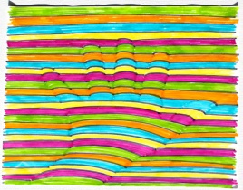  1. 3D Hand prints or objects |  | 2. National look for circles day | 3. Craft: Minion bowling pins
6. Experiment:  Paint on glue | 7. Project stir  Self advocacy  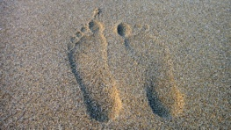 | 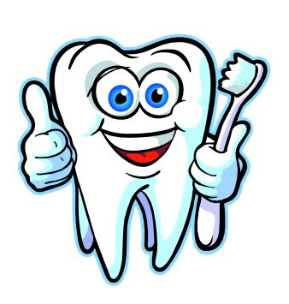  8. hygiene class  Personal care |  | 9. craft: fairy glow jar 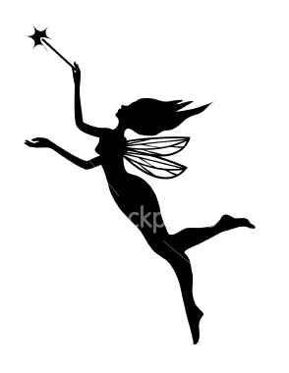 | 10. GAME DAY!!!  Minion Bowling 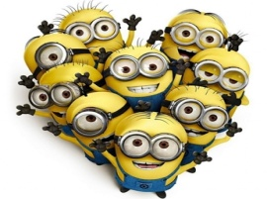
13. ADS staff in-service day  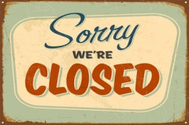 | 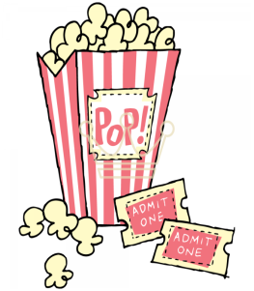  14. Movie day  $10.00  Or  In house movie day ( please turn in activity sheet ) | 15. Craft  Make a bowl out of leave’s 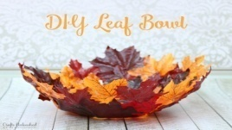 | 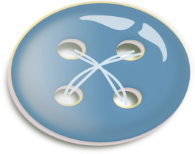  16. National Button Day!  Wear your biggest button |  | 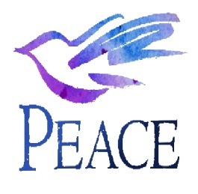  17. National world peace day  Outing  (bowling Bring at least $6.50 )
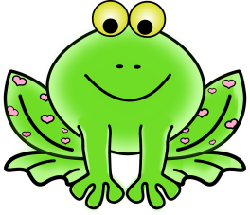  20. Craft Pipe cleaner animals | 21. Nutrition class  Making pumpkin pie for (Thanksgiving feast on 10-22-17 ) | 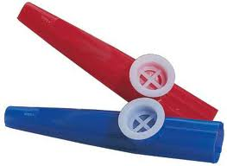  22. feast at Eastland  Bring covered dish ( optional ) | 23.Closed for Holiday 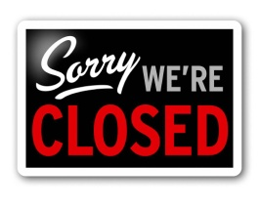 |  | 24. Closed for the Holidays  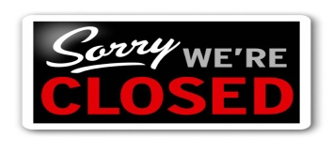
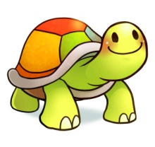  27. Craft  Paper turtles or  Or  Spi – spot  ( $ 3.00 ) | 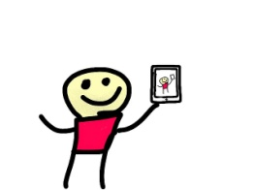  28. Project stir  Knowing yourself | 29. Hygiene Class  Kick into fresh skin ( proper face cleaning ) | 30. In house Clean up  Clean up day 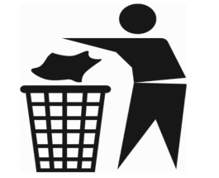 |  | 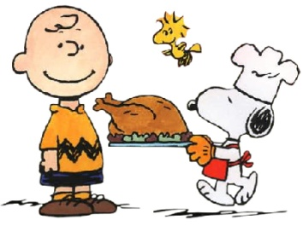
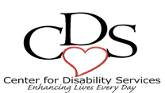
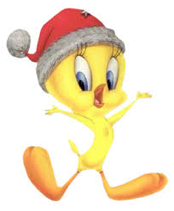
November 2017

