Monday |  | Tuesday | Wednesday |  | Thursday | Friday
 | 1  HEALTHY RELATIONSHIPS  PROJECT STIR |  | 2  CHOOSING ACTIVITIES FOR SEPTEMBER!  WII GAMES |  | 3  VOLUNTEER AT THE GROVE  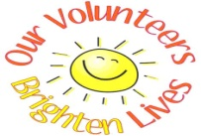 | 4  CLOSED
7  HARTFORD FAIR  $10(MORE MONEY IS OPTIONAL) PACK A COLD LUNCH  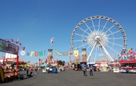 |  | 8  THIS MONTH IN HISTORY!  WORK ON OUR SCRAPBOOKS | 9  WHAT IS ASTROLOGY?  MAKING OUR OWN TELESCOPE |  | 10  VOLUNTEER AT THE GROVE | 11  MOVIE DAY!  SAFETY DRILLS
14  HOW FURNITURE IS MADE  HAVE LUNCH AT THE LAKE* PACK A COLD LUNCH* |  | 15  KARAOKE  SAFETY DRILLS | 16  CELEBRATE AUGUST BIRTHDAYS  ORDER IN FROM PIZZA COTTAGE $10(OPTINAL) |  | 17  VOLUNTEER AT THE GROVE | 18  HISTORY: ORVILLE WRIGHT  KICKSMIX BOOKSTORE *MONEY IS OPTIONAL*
21 BOWLING:  $4.50  PROPERLY ANSWERING THE PHONE |  | 22  CLEANING OUR FISHTANK  BINGO! | 23  WALK TO THE LIBRARY  UNO TOURNAMENT |  | 24  VOLUNTEER AT THE GROVE  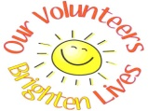 | 25  COFFE AND SOCIALIZATION @ TIM HORTONS $5 *OPTIONAL*
28  MAKING HEALTHY COOKIES  LUNCH AT DAWES *PACK A COLD LUNCH* |  | 29  MORE HERBS LESS SALT DAY!  MAKE OUR OWN COOKBOOK | 30  PROJECT STIR  SCIENCE EXPERIMENT HOW SUGAR CRYSTALIZES | 31  VOLUNTEER AT THE GROVE
AUGUST

